TE 846 Final Project
1) Explore the use of concept maps/graphic organizers in education.
When teaching microeconomics, it is important for students to find the relationship between buyers and sellers. It is vital that students understand and examine the interaction between individual buyers/consumers and sellers/producers and the factors that influence the choices they make. Using a graphic organizer program such as bubbl.us can put students thoughts together in one location. By using this program, students create their own graphic organizers/reviews of what was read in and out of class. This review mechanism, instead of using note cards, reciting, or questions and answers, allows the students to independently put their thoughts into a review of what has been read. This program not only helps students organize their thoughts but also explore relationships among those thoughts. Students will group together different topics read throughout the class and can become more involved in classroom topics. From the gathering of all of this information from a textbook and other readings, student then have a map developed for the beginning of a paper on microeconomics and will be prepared for the unit test. This will be the planning stage of their paper and will not only bring all of their thoughts and knowledge on microeconomics together, but will also help get their paper started.
Throughout the lesson, many attempts should be made to have accommodations for students with multiple disabilities or who are learning the English language. Students with learning disabilities will receive extra help from our special education department either during class or during their study hour. All students are able to share their graphic organizer with their neighbor to gain insight on what is vital or important and what is not. For two days of the review, I will pair all students with someone else in the class. My focus will be on putting my higher-level students with some of the ELL (though I do not have any in my current situation) and LD students. Hopefully, this will create a sense of security for some of the students and enable to them to get ideas from one another. I will also be circulating throughout the room, helping those in need. I will help get students started using bubbl.us and then they will have three days to create a unit review on microeconomics (two days will be spent sharing ideas with a partner). This will tell me if students completed the readings in and out of class, comprehended what was read, and can decipher the main/important points from everything else the text and their supplemental readings offer.
2) Design a lesson that incorporates at least one concept map/graphic organizer: Share your lesson plan with us and be sure to include any accommodations/differentiation you plan for ELL and/or students with LD, etc.
We will be using bubbl.us as a review of what was read throughout the past four weeks in Economics. Students will create their own bubbl and also work with someone in the class for a few days to complete a final product that will be used to write a paper and take a test about our microeconomics unit. The lesson will begin with students listing ideas or thoughts they have come up with over the past four weeks in their reading about microeconomics. We will put all of their topics on the board and discuss what each one means. Topics such as determinants of demand, elasticity, market, equilibrium, surplus, supply, and others should all come up during this discussion. For some of the ELL and LD students I will give them a word and have them describe what they think it means using their textbooks or notes as a reference. This will be an ice-breaker for all and will help keep the activity rolling.
I will then model for them how bubbl.us works and get them started on how their bubbl should take form, looking like what I have created on the page below.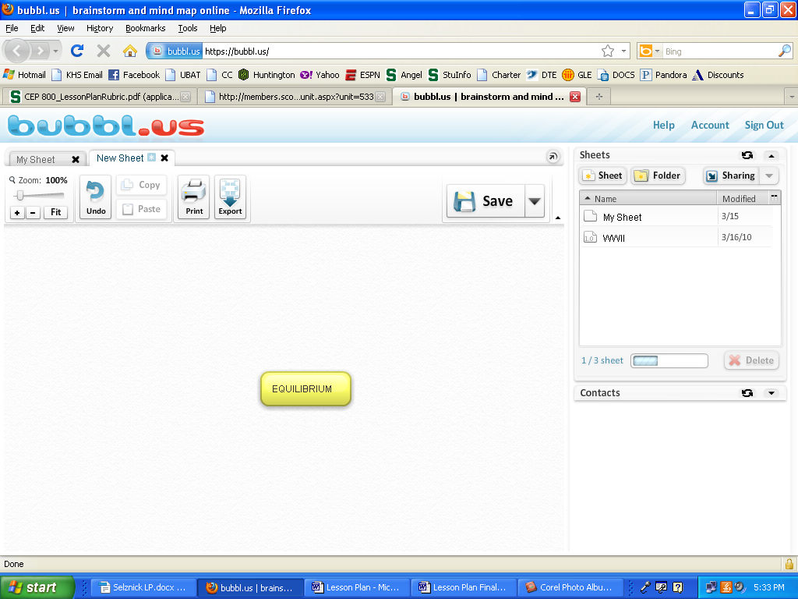
From here most students will go on their own, starting their own unique graphic organizer. I will continue to model the next few branches on mine to assist any ELL or LD learners I may have, so they can get then get started at the same place as the rest of my students. Modeling will get the activity started for all students. Those who are capable of branching out on their own are free to do that and my students who are English language learners, learning disabled, emotionally impaired, or cognitively impaired will get more assistance by myself or our special education staff. They will all be more comfortable in taking the reins of their own review and deciphering what is important and what they need to draw from the past four weeks of study in Economics. They should all be able to piece together many of the concepts they have read and start to create a review that works uniquely for them.
After one day of work on their own, I will give students the final two days to work with a partner (which I will assign). Hopefully this will help any of my lower-level learners out and get them on the right pace. This sharing of ideas enables the ELL and LD students to see what their peers have put on their review that they may have forgotten and they may be able to use to help them put together their graphic organizer and be prepared for the paper they will be writing. On the final day, students will print their bubbl, turn it in to me for a grade, and then begin to use it to write their paper about the past four weeks in Economics. I will be grading on comprehension, vocabulary understanding, and the connecting of ideas from the entire unit.
3) Create a rubric for evaluating student performance.
Microeconomics Bubbl Unit Review | 10 | 9 | 8 | 0
Content | Shows a full understanding of the topic. | Shows a good understanding of the topic. | Shows a good understanding of parts of the topic. | Does not seem to understand the topic very well.
Vocabulary | Student has a full understanding of unit vocabulary. | Student shows a good understanding of unit vocabulary. | Students show some understanding of unit vocabulary. | Student shows no understanding of unit vocabulary.
Comprehension | Student understands the intricacies of the unit. | Student understands most of the unit. | Student shows understanding for a portion of the unit. | Student shows no understanding of the unit.
Partner Work | Almost always listens to, shares with, and supports the efforts of a partner. | Usually listens to, shares with, and supports the efforts of the partner. | Often listens to, shares with, and supports the efforts in the group but sometimes is not a good partner. | Rarely listens to, shares with, and supports the efforts of others in the group. Often is not a good partner.
Supplemental Readings | All supplemental readings were addressed and used properly. | Some use of supplemental readings. | Very little use of supplemental readings. | No supplemental readings addressed, only the textbook used.
Descriptions | Good, in depth descriptions of the unit. | Some description of the unit. | Little analysis of the unit. | No analysis of the unit.
My Overall Grading | Everything is complete, orderly, and looks good. | Almost everything is complete, orderly, and professional. | The work is mediocre and somewhat complete. Missing some information. | Nothing is done completely and the report is not professional at all.
4) Teach the lesson to your tutoring student or your class – Tell us about it.
There were many pros and a few cons to using this graphic organizer program to help my students put their thoughts together from the reading. I thought the students really enjoyed using a program that was different from anything they have used in the past. They took pride in their bubbl and spent a lot of time using the program and gaining familiarity with some of the concepts we covered in the readings. By having students work in pairs, students were able to share ideas and compare their bubbl’s which went very well. My higher-level thinkers were able to pull some information from my learning disabled students and help them organize their bubbl in a way that made sense to them. Instead of filling out a graphic organizer I make or completing a review, students could pull their own ideas from our textbook and other supplemental readings to create a review that would be beneficial to them individually. I also heard many students throughout the few days we spent on this discussing how much fun it was to get out of the room, use new technology, and work with others. I liked the way it worked because I heard a lot of Economics vocabulary being used every day to complete the graphic organizers.
One thing I would change is the fact that I would spend more time modeling how they should piece together and connect their information they pulled from the readings. I feel that through modeling, I can give more guidance and show what I expect in their graphic organizers. One major downfall was that many students only used the textbook as a resource and totally ignored their supplemental readings, which were a large portion of what they have read throughout this unit. By missing these readings they lacked some depth on some of their ideas. Next time I will attempt to model to them how I would use the supplements to add to the textbook to gain the depth and consistency many of them were lacking.
5) Write a reflection about the lesson:
I felt by incorporating this graphic organizer into this unit I was able to grab the students’ attention and keep them focused more on the task at hand. It is easy for them to get distracted and sometimes bored with this material, but I felt the graphic organizer kept them alert and discipline was not a problem. They also learned to be more independent in their learning. Instead of me feeding them notes or information, they pulled what they thought was important from all of our readings together to create their own review that would help them find success. For me as the teacher it was easy to patrol the room and help those in need. Some students needed more assistance than others, but I could constantly patrol the room, put out small fires, and see where each student was in their review.
Below is an example of one of the student’s bubbl. It is obvious to me that this particular student did not spend a lot of time or put forth a ton of effort in creating their graphic organizer. He actually struggled on the test that followed this review. Other students were able to use their graphic organizer as a study tool/review technique that prepared them for the test and put all of their thoughts and readings in one location. If more time was spent by the students putting definitions, explanations, and descriptions of each term in, I think that would have helped these students (like the one below) better comprehend the material. Though this did not necessarily help this student on the test, I was very pleased to see how he was able to group similar topics together throughout his graphic organizer, which is something he consistently struggled with throughout the year.
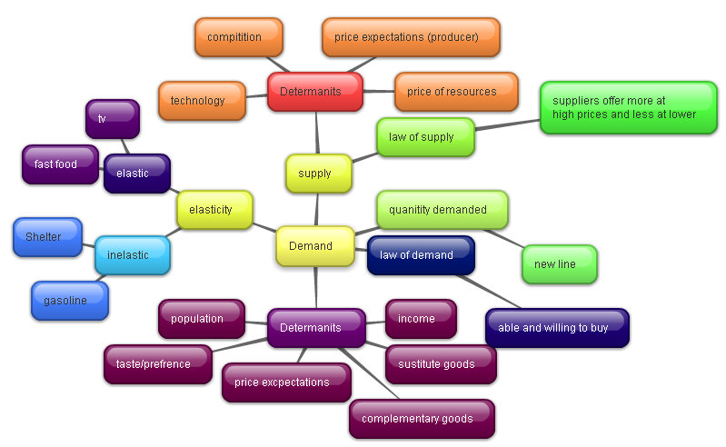

6) Create a list of references for our TE 846 learning community.

Bubbl.us
-The website itself, very easy to set up and play around with.

http://educationaltech-med.blogspot.com/2011/04/bubblus-great-mindmapping-and.html
-Features, how to use the program, videos, and applications

http://specialeducationresources.edublogs.org/2011/03/07/web-2-0-tool-bubbl-electronic-brainstorming/
-Overview of bubbl.us, how to use the program step-by-step, bubbl in the classroom

http://www.multimediatrainingvideos.com/mind/
-Video that could be used to show students how to use bubbl.us

7) Self-evaluation:
While implementing and using a new form of graphic organizer to help my students in my Economics class, I learned that it takes a lot more time and effort on my part to get the students to do the correct things. Until the students got used to using the program bubbl.us, I was running around the room helping students and groups in need. This was not something I anticipated. Also underestimated by me was the importance of modeling to my students. I know if I would have spent more time modeling how to use the program and outlining some of the specifics I was looking for, I would have gotten a much higher quality final product. I will be grouping more of my lower-level learners with my higher-level learners in the future because of the positive outcomes I saw with this project. This went very well and students were able to share their thoughts and ideas with one another about microeconomics.
I plan to use bubbl.us more frequently, and not just as a test review or to help get them organized for an upcoming writing assignment. I plan to use it more as a content map where I can see if students are connecting their thoughts with what we are learning in class. Though it does work well as a review and as an organizational tool for writing, I think there are many more possibilities for this program. I think this graphic organizer is very beneficial to our students and can be used to not only keep them focused, but it also helps them stay organized and engaged in the material. It can be used in subject areas other than Social Studies and can also be used at much younger grade levels than high school.
Though I used this new resource last year in my classroom, I think discussing the pros and cons and putting everything together in one place was very beneficial for me. I have realized that I want to use bubbl.us again in the future to help students keep their thoughts organized and work on using new vocabulary discussed in class and in their readings. If I did not already complete something like this in my teaching situation last year, I would have done it with my case study students to help them with comprehension and organizing their thoughts. I think I benefited tremendously from doing this project and learned a lot about my students’ organizational processes and how they put their thoughts and what we have read onto paper. This was something I saw that needs to be changed and improved, and I will continue to work on this next year with my Economics classes.

